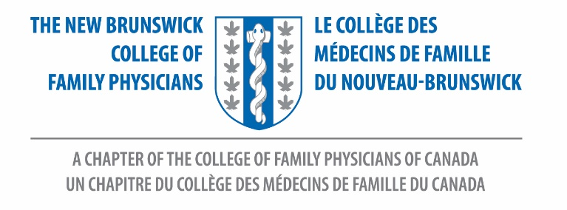

Dear NBCFP Member,
Save the Date:
Annual Meeting of the Members
Wednesday, June 26, 2024
7-8PM on Zoom

Please Register HERE.

NBCFP Proposed Bylaws changes:
A summary of the proposed bylaws changes can be found in ENGLISH and FRENCH. These have been reviewed by the NBCFP Board and CFPC Board and will be presented at the 2024 Annual meeting for Membership approval by vote.
Questions – please contact nbcfp@hostmanagement.ca

Awards
It is that time of year again to nominate your colleagues for NB College of Family Physician awards. We are now accepting nominations for the Family Physician of the Year.
Please complete your nominations by May 15, 2024.
Any questions regarding this process please contact nbcfp@hostmanagement.ca.

NBCFP Family Physician of the Year, 2024
New Brunswick College of Family Physicians invites nominations for our Family Physician of the Year. This Award will recognize an outstanding CFPC member who exemplifies the ideals of family medicine. The Award is adjudicated based on the individual's contribution to family medicine in general, family practice in particular, their community through government, social, or other activities, and the College of Family Physicians of Canada.
This individual will be honoured in person at our upcoming conference which is tentatively scheduled for September/October 2024.

Call for Nominations:
The NB College of Family Physicians is requesting a call for nominations for:
President-Elect
“President Elect. The President Elect shall be a designated spokesperson for the College. In the absence or disability of the Honorary Secretary Treasurer, the President Elect shall perform the duties of this Officer.”

(Bylaws, Section 9.1)

Honorary Secretary Treasurer
“Honorary Secretary Treasurer. The Honorary Secretary Treasurer shall render to the Board whenever required an account of all transactions as Treasurer and of the financial position of the Corporation and shall have such other powers and duties as may be specified by the Board.”

(Bylaws, Section 9.3)
We hope you will consider these positions. We also have other positions available so please don’t hesitate to reach out to our President, Karine Boulay, for further information. Please provide your submission to nbcfp@hostmanagement.ca.

Membership Rate Increase
The decision was made by the Board of Directors to increase the member rate by the COL (cost of living).
Please see below for specific rates:
Category | Previous Rate | 2024 Rate | Increase Amount
Practising Member | $154 | $162 | $8
First Year Practising Member | $77 | $81 | $4
Practising Member (Reduced Fee) | $103 | $108 | $5

Thank you, and we look forward to seeing you at our virtual AMM on Wednesday, June 26th at 7:00PM.

